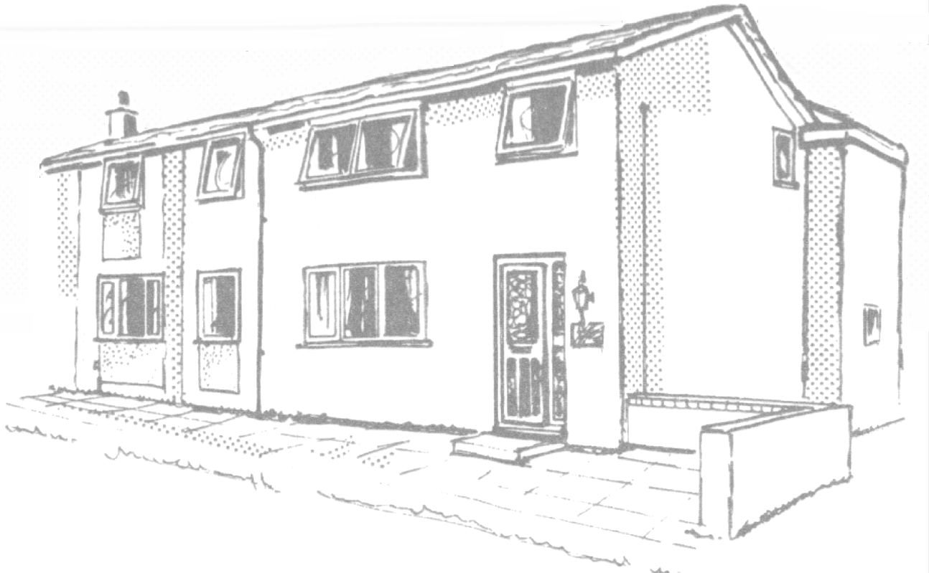 | Oswald House,  33, St. Oswalds Walk,  Newton Aycliffe,  Co. Durham.  DL5 4BQ  Tel. (01325) 300296  Fax. (01325) 314621  E-mail mail@oswaldhouse.co.uk
Residents Contract

Name of Resident: SAMPLE .


Contract Statement

This document sets out the respective rights and responsibilities of the staff and management of Oswald House and ______SAMPLE__________relating to residence in the home. The home aims at all times to reach, and indeed exceed, the National Minimum Standards for Care Homes for Younger Adults. A copy is kept in the home and may be seen on request.

We try to provide a comfortable and happy home and hope that residents will enjoy living here. We will do everything possible to respect the rights of residents in this home, particularly by observing the values of privacy, dignity, independence, choice, civil rights and fulfilment which can be threatened by living in a communal environment and having to cope with disabilities.
We recognise that providing good care is a co-operative process and we will attempt to consult residents and, where appropriate, their relatives, friends and representatives at all times and as fully as possible. This document should be read and interpreted in the light of these principles.

Note: The following section is not appropriate for residents coming to the home for respite, phased care, rehabilitation, intermediate care, or other short-term or recurring periods.
Residence

Trial period

Residence in the home for the first three months will be on a trial basis. If during or at the end of the period either the resident or the home's management regards the arrangement as unlikely to be satisfactory for the long term, residence can be terminated with reasonable notice from either side and the resident will vacate the home at a time agreed.

Permanent residence

The staff and management of the home will make every effort to provide the resident with a permanent place of residence including wherever possible through periods of sickness. Advice will be taken from the appropriate health professionals in situations where it is considered that the home is temporarily or permanently unable to provide for the resident's medical or nursing needs.

Termination

In the event that either the management of the home finds that the home is no longer able to accommodate the resident appropriately or the resident wishes to leave the home for any reason, either side will normally give four weeks' notice of termination of residence. A shorter period of notice will be applicable only in situations involving emergencies.


Fees

The fees payable start from £476.93 per week for basic care, payable four weeks in advance by cheque, standing order or cash.

Fees for periods of less than a week are calculated at a daily rate of 1/7 of the weekly fee, with part days calculated at the full daily rate.

The fees will be paid by the benefits agency and Social Care and Health.

Fees include all care and accommodation costs, food and drink, heating and lighting, laundry done on the premises
and any other onsite staff services.
Fees do not cover the costs of newspapers and periodicals, hairdressing, dry cleaning, chiropody, treatment by dentists or opticians, use of the homes vehicles, 1:1 support while socialising or attending appointments or the purchase of clothing and personal effects.
Fees are reviewed annually. If a resident requires additional care, however, it may be necessary to increase the fee. The home will give four weeks' notice of any increase in fees.

The Resident's Room
The resident will have exclusive [or shared] use of the allocated room which will be treated as far as possible as his or her private space. Residents are welcome to bring to their rooms personal items and any furniture they wish to use which can be safely accommodated in the space. Furnishing of the resident's room will include at least the following.
• A clean comfortable bed suitable for the resident's needs.
• Bed linen.
• Curtains or blinds.
• A mirror.
• Overhead and bedside lighting.
• Comfortable seating for two people.
• Drawers and enclosed hanging space for clothes.
• Two accessible double electric sockets.
• A table to sit at and a bedside table.
• A wash hand basin [or specified facilities].
• Carpets or equivalent.
• Lockable storage space for medication, money and valuables.
• Keys to the room and storage space (unless a risk assessment in the care plan indicates otherwise).
• In double rooms screens to ensure privacy for personal care.

If the resident has made a positive choice to share a room and the other place in the room becomes vacant, he or she will have the opportunity to move to a different room if desired.

Personal Possessions
Residents are encouraged to have personal possessions, subject to health and safety and fire risk assessments, which remain their property. (Residents wishing to bring a pet into the home should discuss the matter with the manager who will make every effort to meet reasonable requests.) Items of significant value should be passed to the management for safe-keeping. The staff will attempt to provide security for residents' possessions but no responsibility can be accepted for items retained in residents' own rooms. All clothing should be marked with the resident's name or an identifiable mark. The home will make every effort to prevent damage to clothing.

Health

The home will promote and maintain the resident's health and ensure access to health care services. In particular it will do the following.
• Support self-care wherever possible.
• Maintain personal and oral hygiene.
• Identify pressure sores or the risk of developing pressure sores and undertake appropriate action.
• Monitor psychological health and ensure that preventive and restorative care is provided.
• Provide appropriate opportunities for exercise and physical activities.
• Identify and act on any risk of falling.
• Regularly assess and act on the resident's nutritional needs and monitor weight gain or loss.
• Enable residents to register with a GP of their choice, subject to the GP's agreement.
• Facilitate access to specialist medical, nursing, dental, pharmaceutical, therapeutic services, and hospital and community health care, as required.
• Ensure access to hearing tests and sight tests and to appropriate aids.
• Provide information and advice about entitlements to health care.
• Inform the residents' next of kin or representative of serious illness or death.

Medication
The home maintains a clear policy and stringent procedures in accordance with Department of Health guidelines for all aspects of the handling of residents' medication. Records are kept of whether each resident wishes to deal with their own medication or pass that responsibility to staff, and of any medication in use whether or not it is self-administered.

Care
The management undertakes to make available sufficient staff to meet the residents' care needs. A full assessment of care needs will be carried out before admission and needs will be reviewed regularly. A residents plan of care will be drawn up with the full involvement of the resident and reviewed at least monthly. The plan of care will set out in detail the action needed to be taken by care staff to ensure that all aspects of the health, personal and social care needs of the resident are met.

Insurance

The home is properly insured and will advise residents on insurance cover for personal property.

Health and Safety
The management will ensure, as far as practical, the health, safety and welfare of residents, including compliance with relevant legislation and the Department of Health guidance.

To comply with fire regulations and for the safety and comfort of residents and staff, smoking is not permitted in any areas.

Visitors
Visitors are welcome at any reasonable time. Visitors can be provided with meals at a reasonable price and with notice; drinks are available free of charge.

In the interest of general safety visitors are asked to inform staff on duty of their arrival and intended departure and if a resident is leaving the premises with them.

Complaints
The home has a user friendly complaints procedure which can be seen on request. Any complaint made by or on behalf of a resident will be investigated and dealt with under the procedure.

Registration

The home is registered with Care Quality Commission

Signed: _______________________ (Registered Manager)

Signed: ________________________ (Resident)

Date: _____________________

